Frequency Education Tool

What is it?
- Frequency is the number of visits per week set at initial evaluation, to include the evaluation and discharge visits.
Where can I find it? (BELOW)
- PT/OT/ST Frequency:
  - It is important to mix frequencies and not use a ‘cookie cutter’ frequency such as 2w8, unless you can back it in your evaluation/SOC and is agreeable by the contracted company. Front loading visits is recommended with new PDGM changes in 2020.
  - Frequency goes from Sunday to Saturday!!!!! If you can’t make up a visit during the Medicare work week, you either need to change frequency or complete a missed visit. Missed Visits are not recommended as contracted company’s track these weekly and is often frowned upon FYI.
  - TOTAL frequency means the number of visits by all therapists. Example, PT (2w3), OT (2w3), ST (2w3) = 18 total visits. We should never exceed 22 visits in a certification period (60 days from SOC date) without discussing with the contracted company. When in doubt, go to patient manager in ALPINE KINNSER, click the tab “ALL THERAPY” which will show the number of visits total by all therapists.
  - Effective dates must be the same as the evaluation date, to include 1w1 for the evaluation for example.
  - The certification period must be considered for all frequencies.
  - The frequency in ZUUM must match what you are completing in the contracted company EMR system.
  - Example: PT frequency is 2w2, 1w5 = 9 PT visits, effective 3/11/2020 – this includes one visit for the evaluation, re-evaluation and discharge. See below:

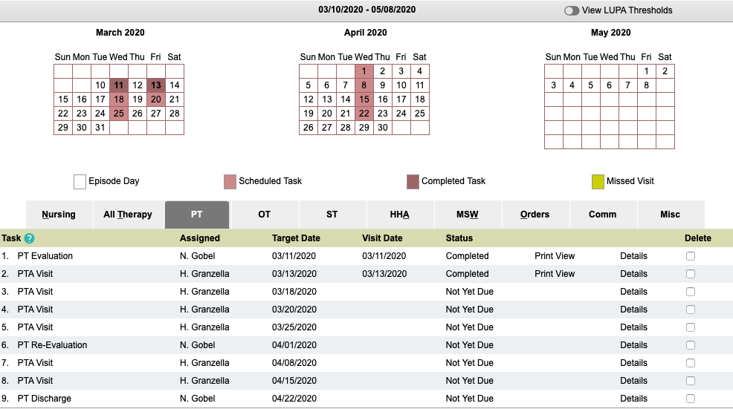
  - Example: OT frequency is 1w2, 2w1, 1w1 = 5 total OT visits, effective 3/14/2020. This includes one visit for the evaluation, re-evaluation and discharge. See below:
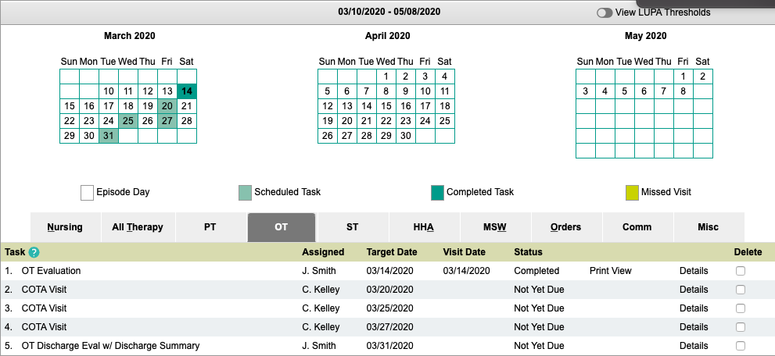

  - Example: SLP frequency is 1w1, 2w3, 1w2 = 9 total SLP visits, effective 2/13/2020. This includes one visit for the evaluation, re-evaluation and discharge. See below:

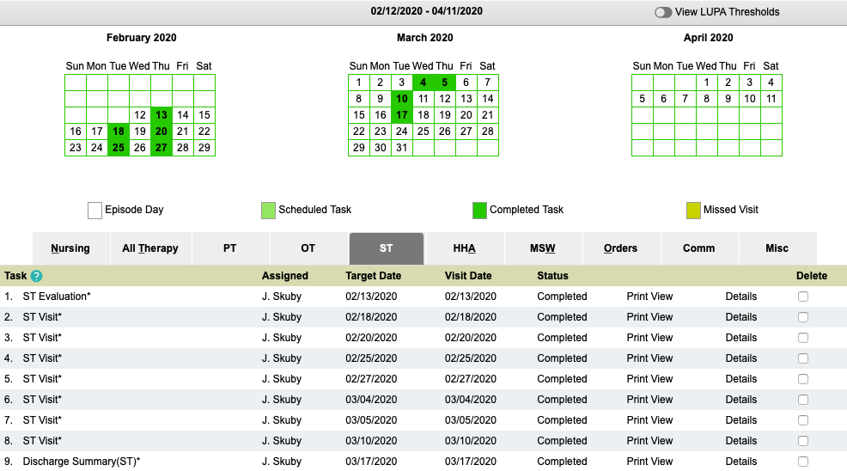

- ASSISTANTS frequency:
  - A PT or OT must complete a re-evaluation every 30 days in place of a visit by an assistant.
  - Keep in mind that the first visit of the frequency is done by the evaluating therapist. The last visit is completed by the therapist, and if a re-evaluation is needed it must also be completed by the PT or OT.
  - When in doubt, look in ALPINE KINNSER under patient manager to view the calendar of plotted visits.
  - Make sure to review the evaluation and re-evaluation completed by the PT or OT prior to seeing the patient for treatment to ensure accuracy of the frequency, to follow orders, and follow the POC.

What to watch for:
- Change in frequency in ZUUM, ALPINE KINNSER and in the contracted company EMR (requires VO from the MD, new order and comm note in some cases)
- HOLD status (requires a MD order, delete remaining visits in ZUUM and Kinnser during a HOLD status)
- Make sure every patient is re-evaluated every 30 days, at least! It is everyone responsibility to plan ahead for re-evaluations.
- ASSISTANTS: Communicate with the evaluating/supervising clinician often for care coordination and questions regarding frequency as needed.

